**Yearly Airline Performance Report 2019**

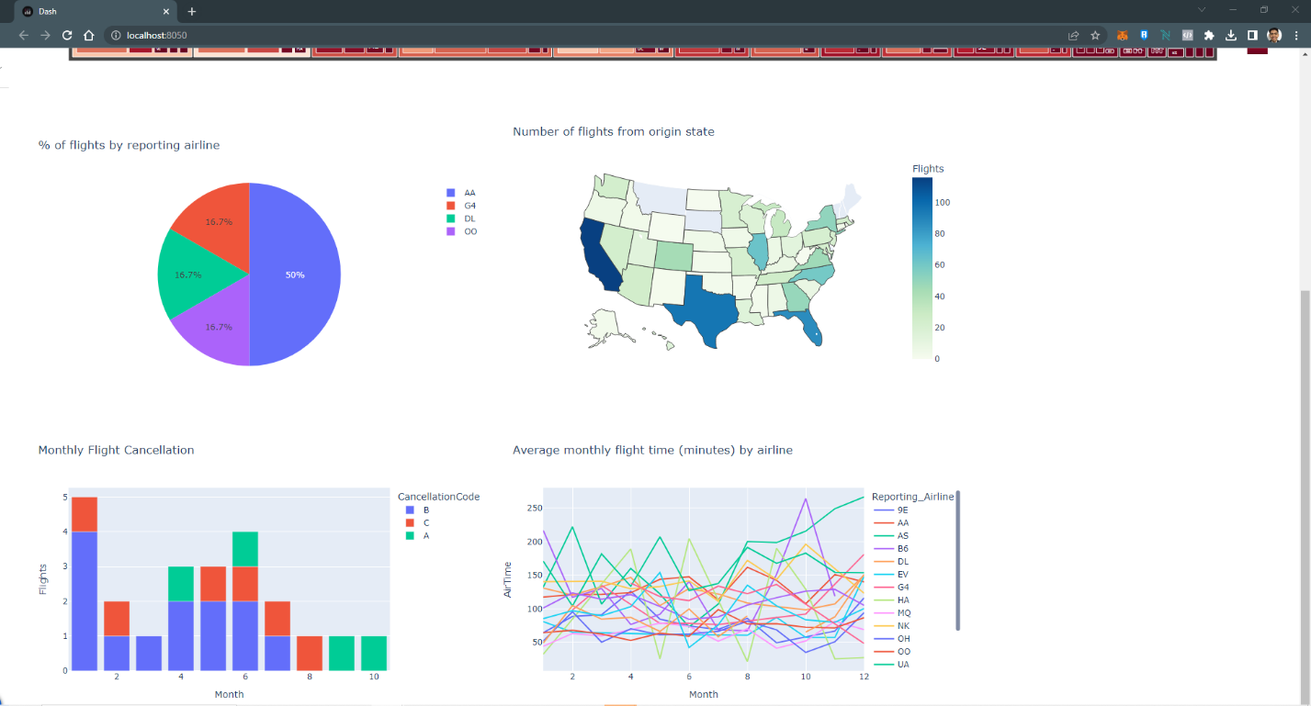

**Yearly Airline Performance Report 2015**

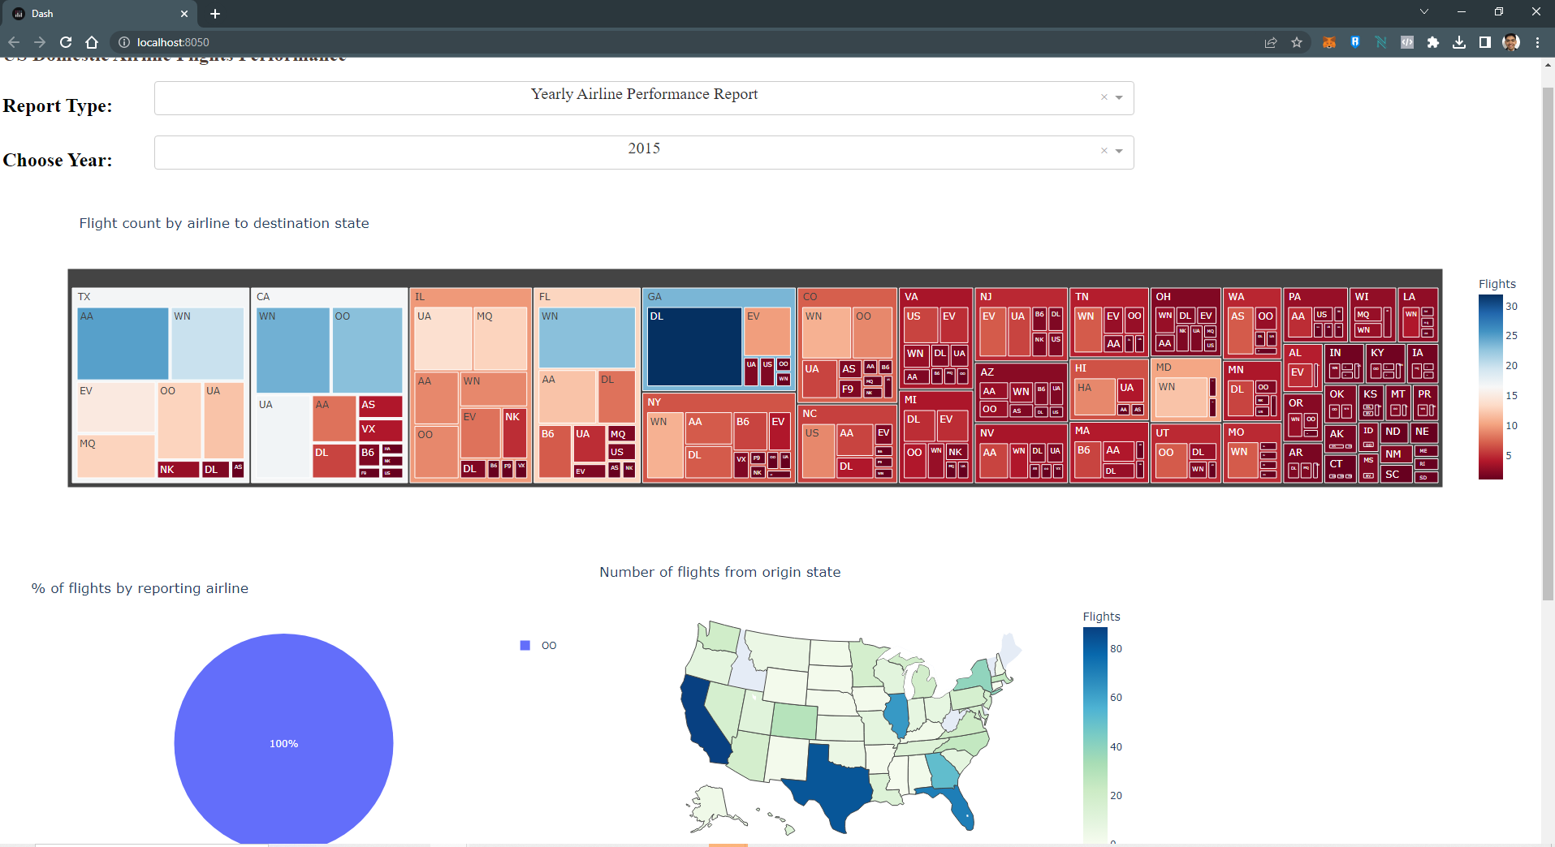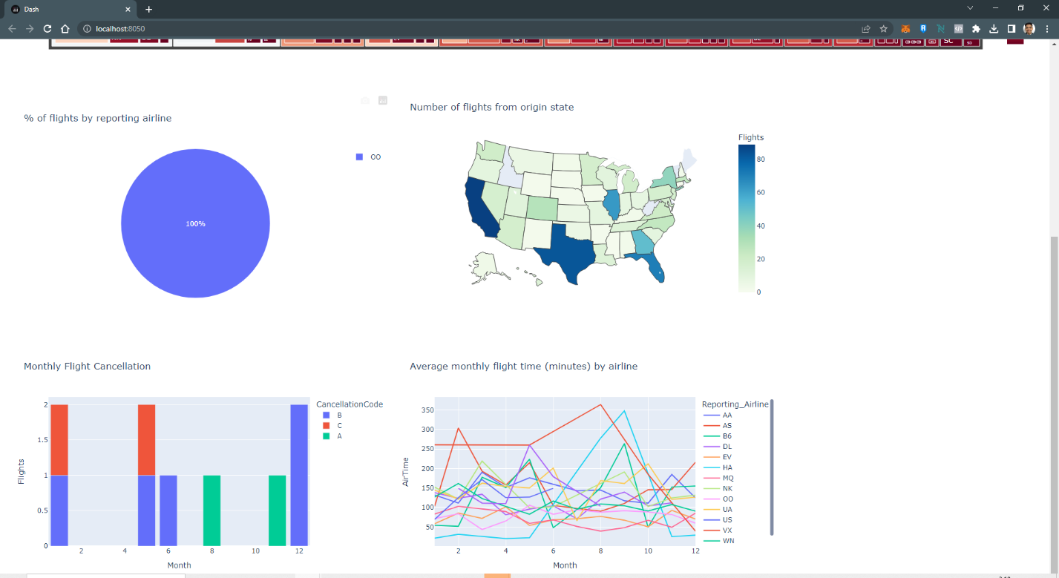

**Yearly Airline Delay Report 2019**

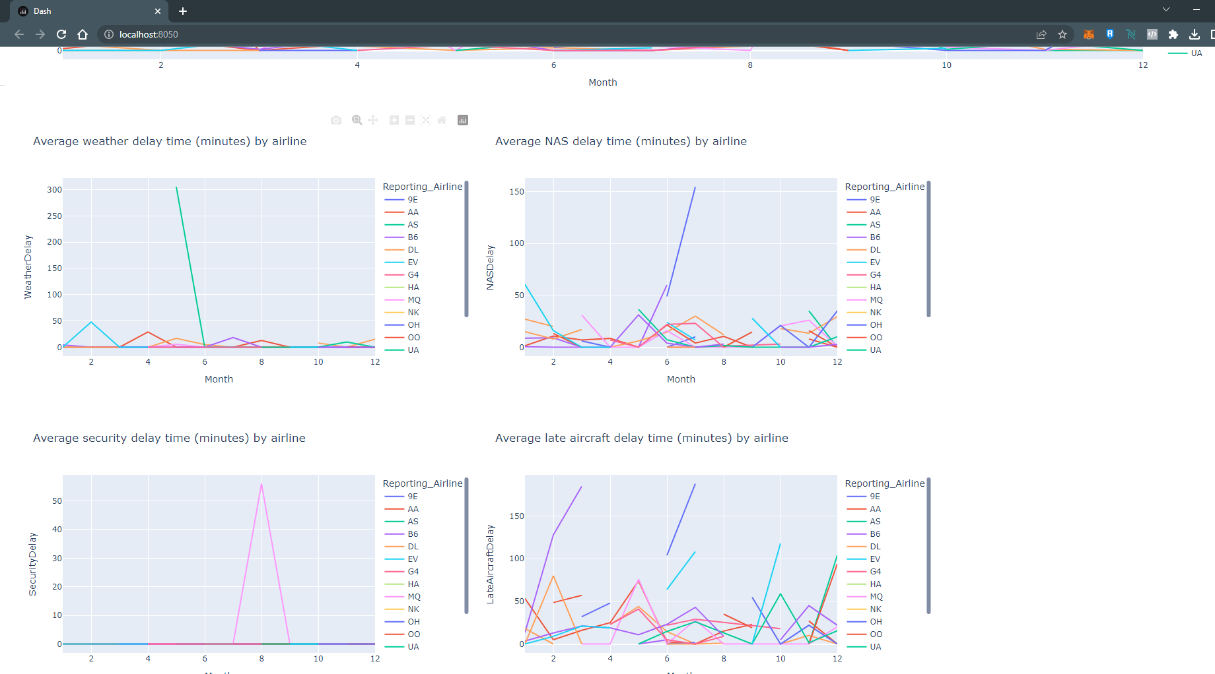

**Yearly Airline Delay Report 2008**